Manuscript tile (Manuscript title should be written in sentence format)
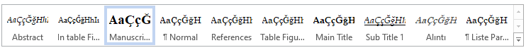

Abstract
Abstract should be written with a minimum of 150 words and a maximum of 300 words. "Abstract" should be selected in Microsoft word styles. Abstract should be written with a minimum of 150 words and a maximum of 300 words. "Abstract" should be selected in Microsoft word styles. Abstract should be written with a minimum of 150 words and a maximum of 300 words. "Abstract" should be selected in Microsoft word styles. Abstract should be written with a minimum of 150 words and a maximum of 300 words. "Abstract" should be selected in Microsoft word styles. Abstract should be written with a minimum of 150 words and a maximum of 300 words. "Abstract" should be selected in Microsoft word styles. Abstract should be written with a minimum of 150 words and a maximum of 300 words. "Abstract" should be selected in Microsoft word styles. Abstract should be written with a minimum of 150 words and a maximum of 300 words. "Abstract" should be selected in Microsoft word styles.
Keywords:
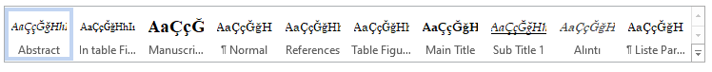

Introduction (main title)
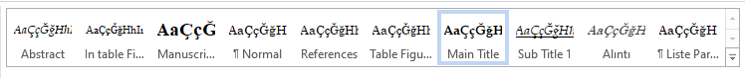
While writing Manuscript, the "Normal" style of Microsoft Word program should be used. Main titles should be written in the style of "Main Title" and there should be no numbering.
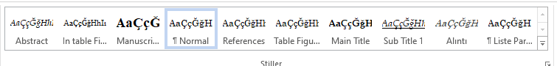

Literature Review(main title)

Concept one (Sub Title 1)

Concept two (Sub Title 1)

Tablo 1: Table title
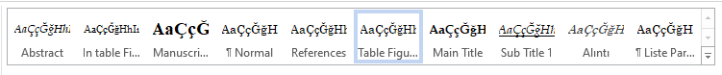
Table | Table | Table | Table
Table | Table | Table | Table
Table | Table | Table | Table
Table | Table | Table | Table
Source: …

While writing the titles of the Table and Figures, the "Table Figure Title" style should be used. Titles of the tables should be on the table, and the titles of the figures should be under the figure. Reference should be given for each table and figure. (Duarte Pimentel & Conceição de Paula, 2019; Mil & Dirican, 2018; Özdemir & Yılmaz, 2016; Sati, 2019)

Tablo 2: Table title
Table | Table | Table | Table
Table | Table | Table | Table
Table | Table | Table | Table
Table | Table | Table | Table
Source: …

References (main title)
Duarte Pimentel, T., & Conceição de Paula, S. (2019). Performance assessment protocol: notes towards an academic management tool based on a Brazilian tourism course. Journal of Multidisciplinary Academic Tourism, 1(4), 15–35. https://doi.org/10.31822/jomat.543115
Mil, B., & Dirican, C. (2018). Industry 4.0 Technologies and Its Effects On Tourism Economics. Journal of Multidisciplinary Academic Tourism, 3(1), 1–9. https://doi.org/10.31822/jomat.347736
Özdemir, E. G., & Yılmaz, V. (2016). A Practical Study on Accomodation Companies in Nevşehir Abour Determining Factors of Competative Advantages. Journal of Multidisciplinary Academic Tourism, 1(1), 61–80. https://doi.org/https://dx.doi.org/10.31822/jomat.288709
Sati, V. P. (2019). Potential and Forms of Sustainable Village Tourism in Mizoram, Northeast India. Journal of Multidisciplinary Academic Tourism, 1(4), 49–62. https://doi.org/10.31822/jomat.527278
